LAB EXERCISE : 13
EMPLOYEE REGISTRATION USING SPRING BOOT AND DJANGO

1 | Eclipse Version : Eclipse IDE for Java Developers – 2026-09 M2 / development build ---https://mirror.library.ucy.ac.cy/eclipse/oomph/epp/2026-06/R/eclipse-inst-jre-win64.exe
2 | Employee file extact the downloads -- Eclipse → Project Explorer / Package Explorer --- https://start.spring.io/starter.zip?type=maven-project&language=java&dependencies=web%2Cdata-jpa%2Cmysql%2Cthymeleaf&groupId=com.example&artifactId=employee&name=EmployeeRegistration&packaging=jar&javaVersion=17&utm_source=chatgpt.com

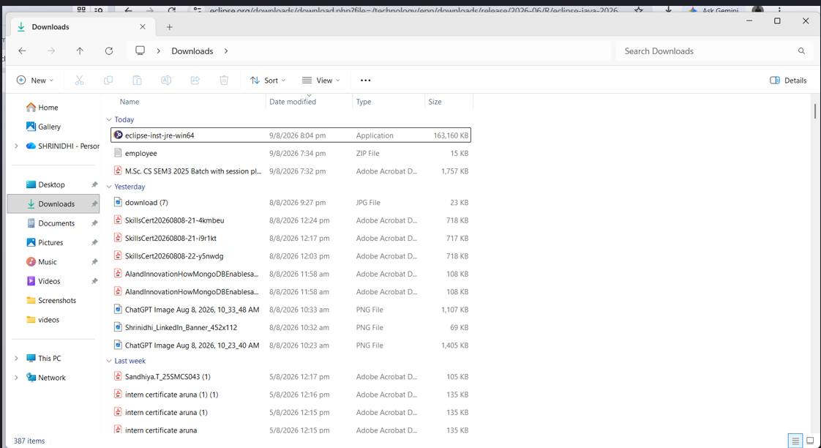

Click it eclipse file on downloads
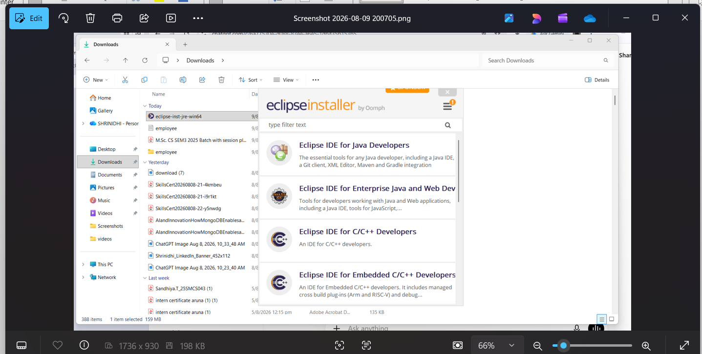
Click the eclipse ide for java developers
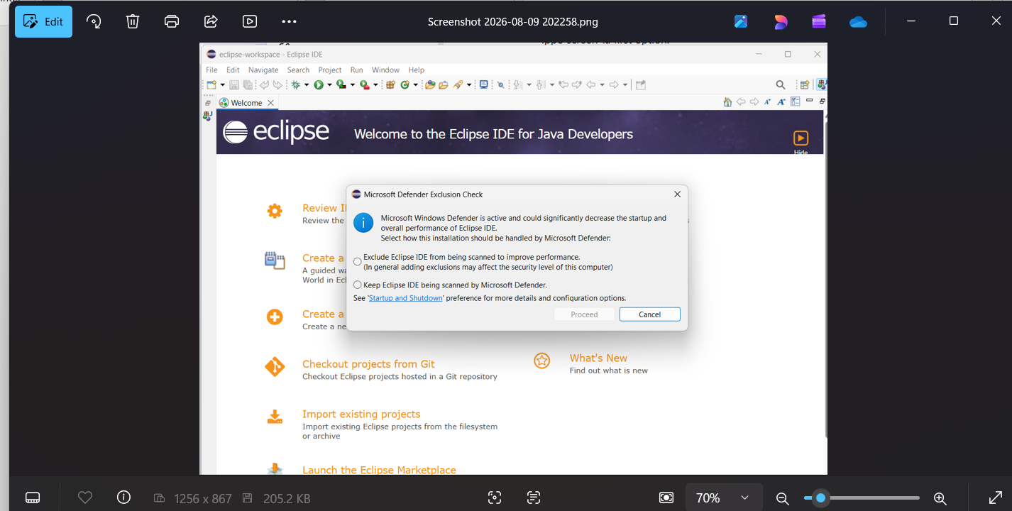
Click the execute and then proceed
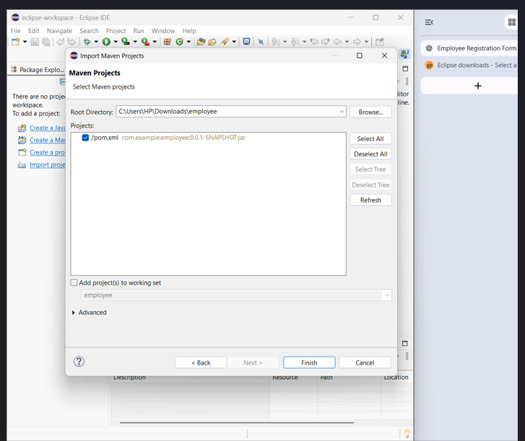
Finsh
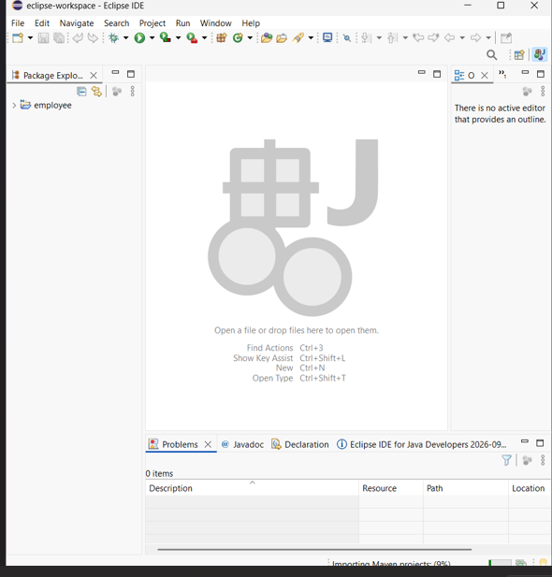Finally tools is open
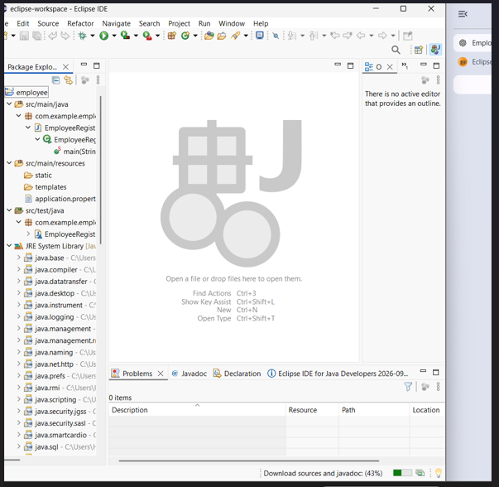

CREATING MODEL
Left sidecom.example.employee packagerightclick
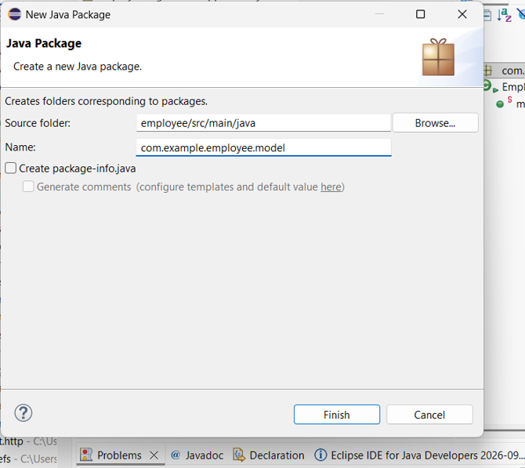

Step 2: Employee.java create
com.example.employee.model
packageRight Click New → ClassEmployee

employee.java replace the code
package com.example.employee.model;

import jakarta.persistence.Entity;
import jakarta.persistence.GeneratedValue;
import jakarta.persistence.GenerationType;
import jakarta.persistence.Id;

@Entity
public class Employee {

@Id
@GeneratedValue(strategy = GenerationType.IDENTITY)
private Long id;

private String name;
private String email;
private String phone;
private String department;
private String designation;
private double salary;

public Employee() {
}

public Long getId() {
return id;
}

public void setId(Long id) {
this.id = id;
}

public String getName() {
return name;
}

public void setName(String name) {
this.name = name;
}

public String getEmail() {
return email;
}

public void setEmail(String email) {
this.email = email;
}

public String getPhone() {
return phone;
}

public void setPhone(String phone) {
this.phone = phone;
}

public String getDepartment() {
return department;
}

public void setDepartment(String department) {
this.department = department;
}

public String getDesignation() {
return designation;
}

public void setDesignation(String designation) {
this.designation = designation;
}

public double getSalary() {
return salary;
}

public void setSalary(double salary) {
this.salary = salary;
}
}

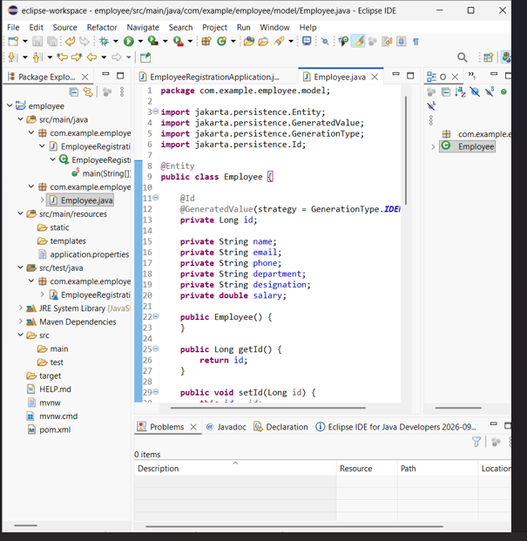

Next Step — Repository create
Left sidecom.example.employee package right-click (Then)New → PackageName
com.example.employee.repository Finish.
repository package
Right Click → New → InterfaceName:EmployeeRepository
EmployeeRepository.java open
package com.example.employee.repository;

import org.springframework.data.jpa.repository.JpaRepository;

import com.example.employee.model.Employee;

public interface EmployeeRepository extends JpaRepository<Employee, Long> {

}
Step 3 — Controller create
Left side com.example.employee package right-click New → Package
Name:
com.example.employee.controller
→ Finish
Controller class create
controller packageRight Click → New → ClassNameEmployeeController
→ Finish
Paste that code:
package com.example.employee.controller;

import org.springframework.beans.factory.annotation.Autowired;
import org.springframework.stereotype.Controller;
import org.springframework.ui.Model;
import org.springframework.web.bind.annotation.GetMapping;
import org.springframework.web.bind.annotation.PostMapping;

import com.example.employee.model.Employee;
import com.example.employee.repository.EmployeeRepository;

@Controller
public class EmployeeController {

@Autowired
private EmployeeRepository employeeRepository;

@GetMapping("/")
public String showForm(Model model) {

model.addAttribute("employee", new Employee());

return "employee";
}

@PostMapping("/register")
public String registerEmployee(Employee employee) {

employeeRepository.save(employee);

return "success";
}
}

OUTCOME IMAGES UPLOAD IT .PLEASE, KINDLY CHECK THIS IMAGES.

CONTROLLER CODE IMAGE:
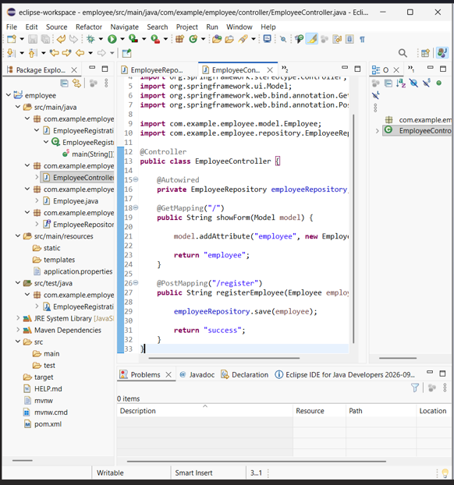
RESPOISTARY IMAGE:
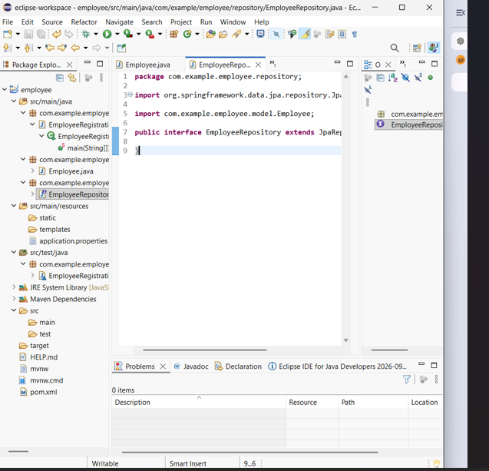
MYSQL SETUP :
Mysql download link | https://dev.mysql.com/downloads/?utm_source=chatgpt.com

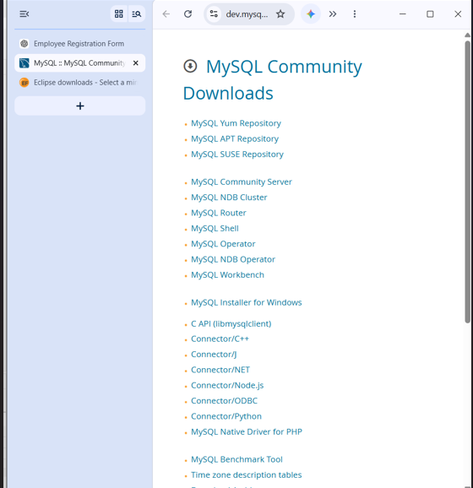
Mysql installer for windows click it.
https://dev.mysql.com/downloads/installer/?utm_source=chatgpt.com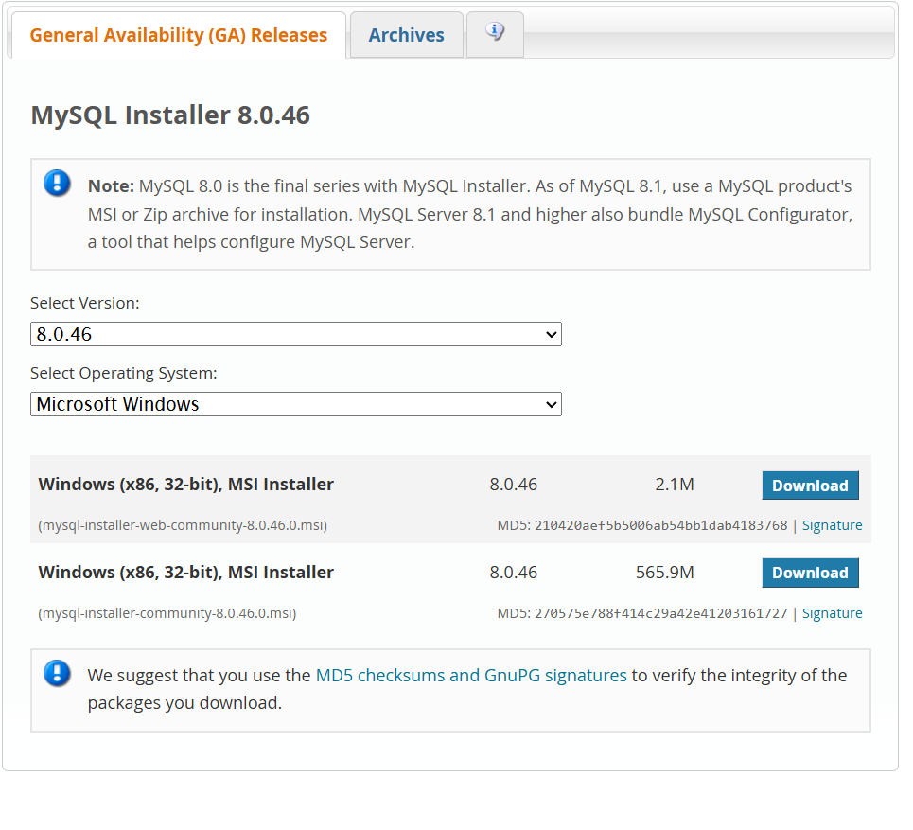
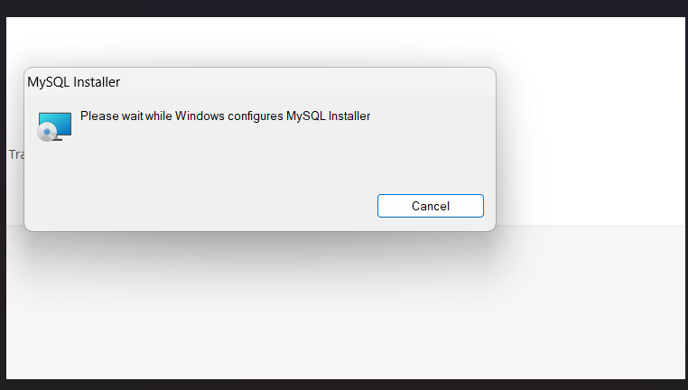
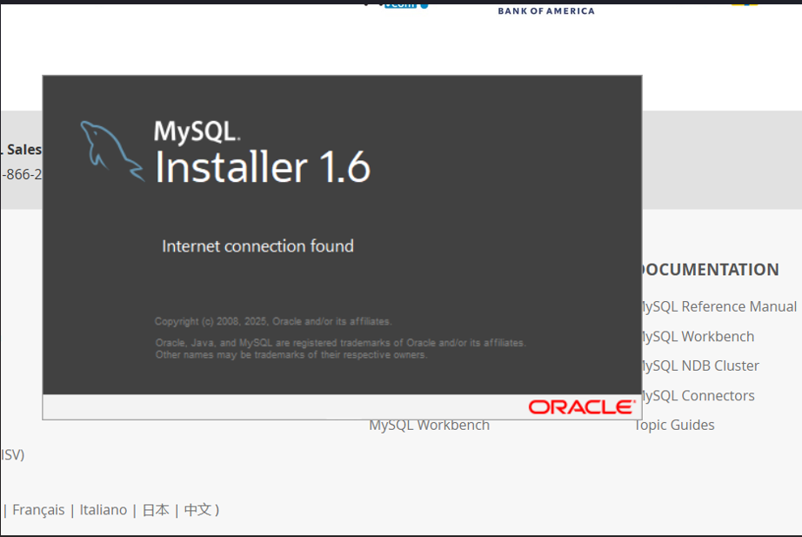
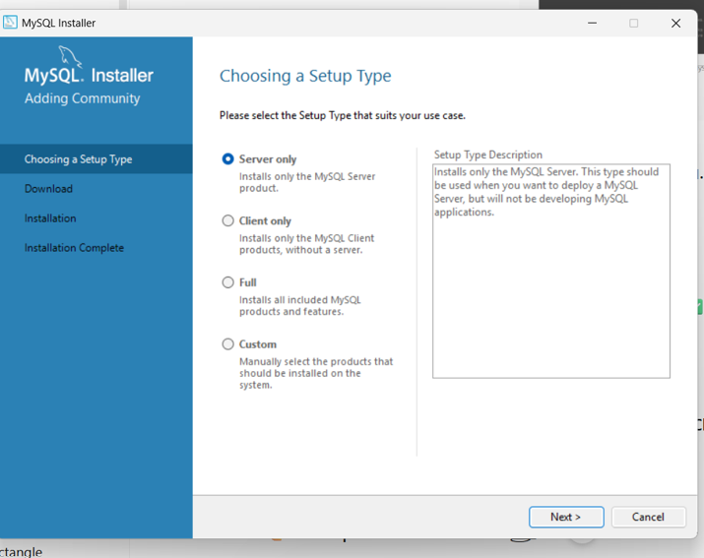
Custom click it.
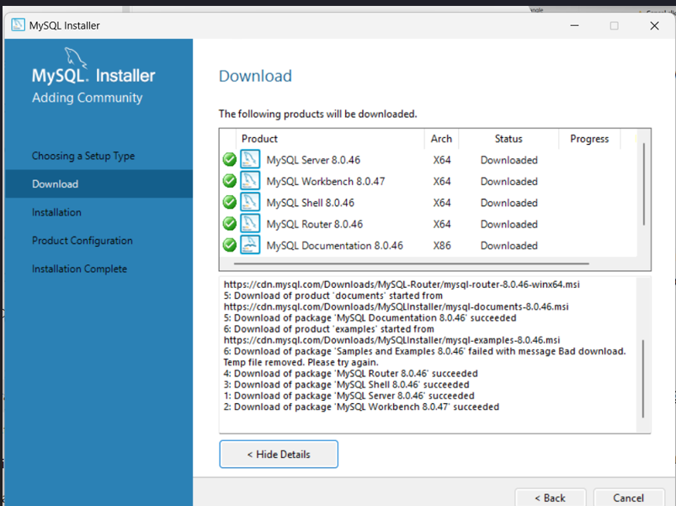
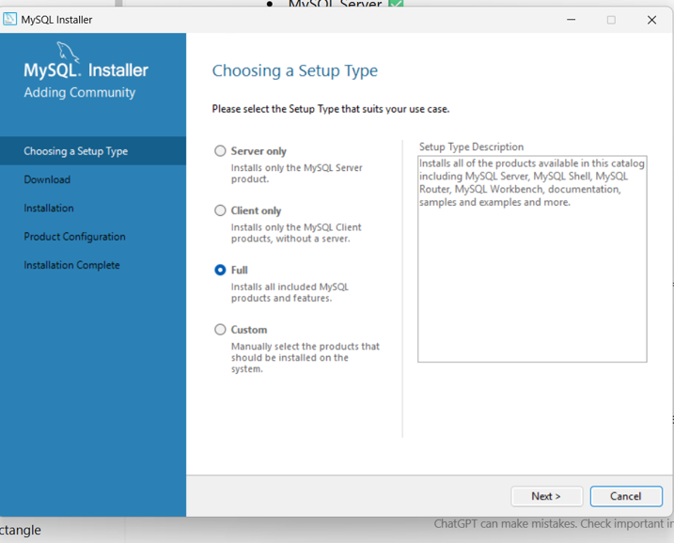
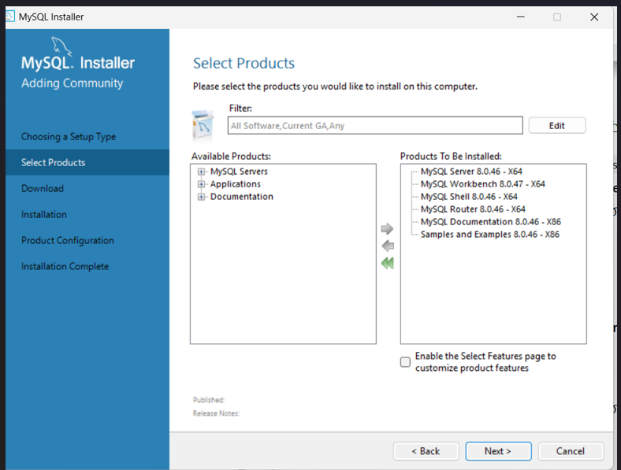
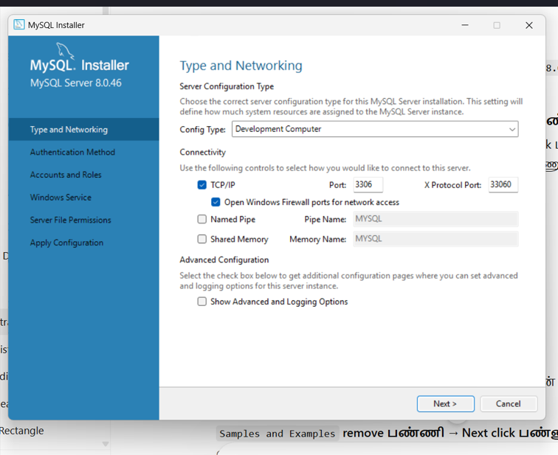

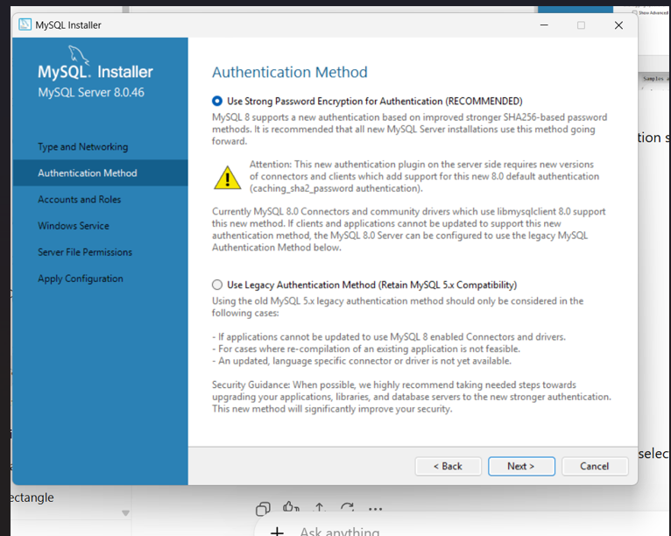
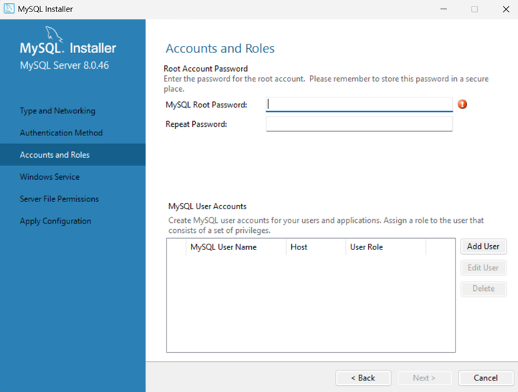
Password : root123
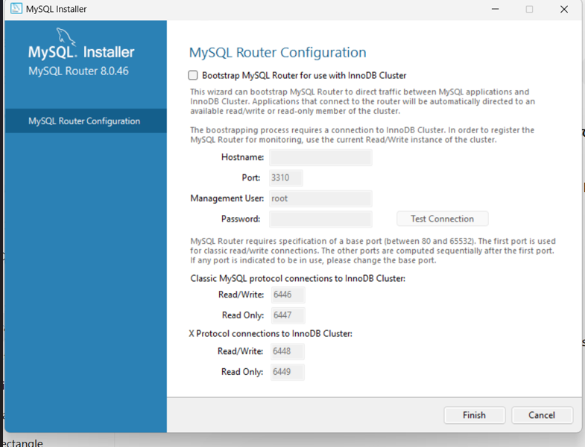
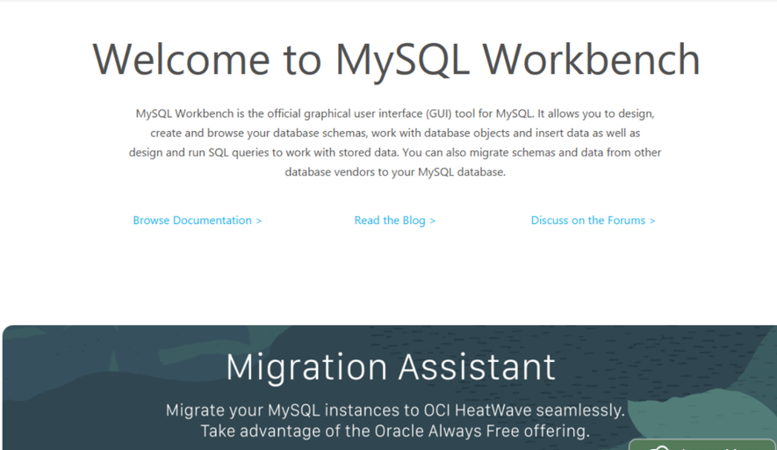
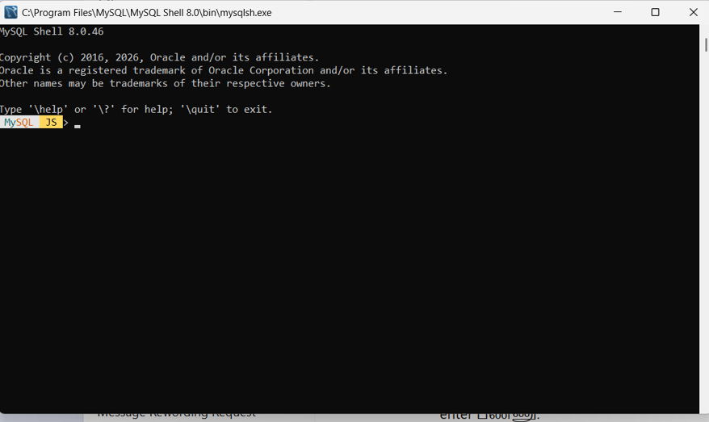
Application properties in eclipse ide:
spring.datasource.url=jdbc:mysql://localhost:3306/employee_db
spring.datasource.username=root
spring.datasource.password=root123

spring.jpa.hibernate.ddl-auto=update
spring.jpa.show-sql=true

spring.thymeleaf.cache=false

server.port=8080 or 8081

again replace code of employee.html
<!DOCTYPE html>
<html xmlns:th="http://www.thymeleaf.org">
<head>
<meta charset="UTF-8">
<title>Employee Registration</title>

<style>
body {
font-family: Arial, sans-serif;
background: #f2f4f7;
margin: 0;
padding: 0;
}

.container {
width: 450px;
margin: 50px auto;
background: white;
padding: 30px;
border-radius: 10px;
box-shadow: 0 4px 15px rgba(0,0,0,0.15);
}

h2 {
text-align: center;
color: #333;
margin-bottom: 25px;
}

label {
display: block;
margin-top: 15px;
margin-bottom: 5px;
font-weight: bold;
}

input {
width: 100%;
padding: 10px;
box-sizing: border-box;
border: 1px solid #ccc;
border-radius: 5px;
}

button {
width: 100%;
margin-top: 25px;
padding: 12px;
background: #1976d2;
color: white;
border: none;
border-radius: 5px;
font-size: 16px;
cursor: pointer;
}

button:hover {
background: #125ca1;
}
</style>
</head>

<body>

<div class="container">

<h2>Employee Registration Form</h2>

<form th:action="@{/register}" th:object="${employee}" method="post">

<label>Name</label>
<input type="text" th:field="*{name}" placeholder="Enter name" required>

<label>Email</label>
<input type="email" th:field="*{email}" placeholder="Enter email" required>

<label>Phone</label>
<input type="text" th:field="*{phone}" placeholder="Enter phone" required>

<label>Department</label>
<input type="text" th:field="*{department}" placeholder="Enter department" required>

<label>Designation</label>
<input type="text" th:field="*{designation}" placeholder="Enter designation" required>

<label>Salary</label>
<input type="number" step="0.01" th:field="*{salary}" placeholder="Enter salary" required>

<button type="submit">Register Employee</button>

</form>

</div>

</body>
</html>
Again replace code employee.controller.java
package com.example.employee.controller;

import org.springframework.beans.factory.annotation.Autowired;
import org.springframework.stereotype.Controller;
import org.springframework.ui.Model;
import org.springframework.web.bind.annotation.GetMapping;
import org.springframework.web.bind.annotation.PostMapping;

import com.example.employee.model.Employee;
import com.example.employee.repository.EmployeeRepository;

@Controller
public class EmployeeController {

@Autowired
private EmployeeRepository employeeRepository;

@GetMapping("/")
public String showForm(Model model) {

model.addAttribute("employee", new Employee());

return "employee";
}

@PostMapping("/register")
public String registerEmployee(Employee employee) {

employeeRepository.save(employee);

return "redirect:/";
}
}
Check it code of employee controller.java
package com.example.employee.controller;

import org.springframework.beans.factory.annotation.Autowired;
import org.springframework.stereotype.Controller;
import org.springframework.ui.Model;
import org.springframework.web.bind.annotation.GetMapping;
import org.springframework.web.bind.annotation.PostMapping;

import com.example.employee.model.Employee;
import com.example.employee.repository.EmployeeRepository;

@Controller
public class EmployeeController {

@Autowired
private EmployeeRepository employeeRepository;

@GetMapping("/")
public String showForm(Model model) {

model.addAttribute("employee", new Employee());

return "employee";
}

@PostMapping("/register")
public String registerEmployee(Employee employee) {

employeeRepository.save(employee);

return "redirect:/";
}
}
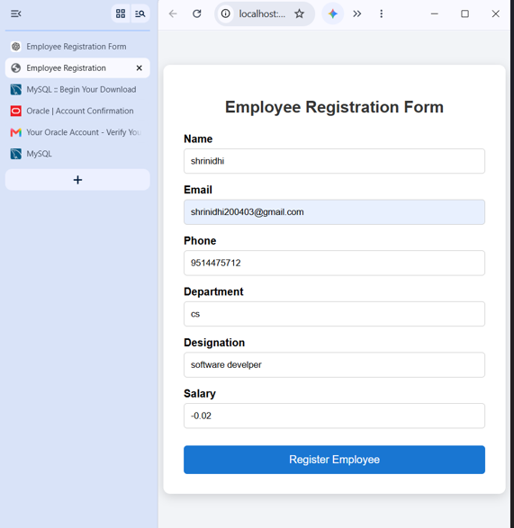
Mysql:
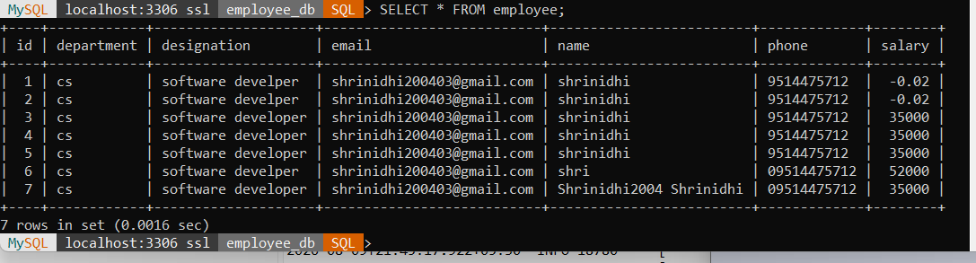

JAVA ECLIPSE + PYTHON DJANGO =MYSQL

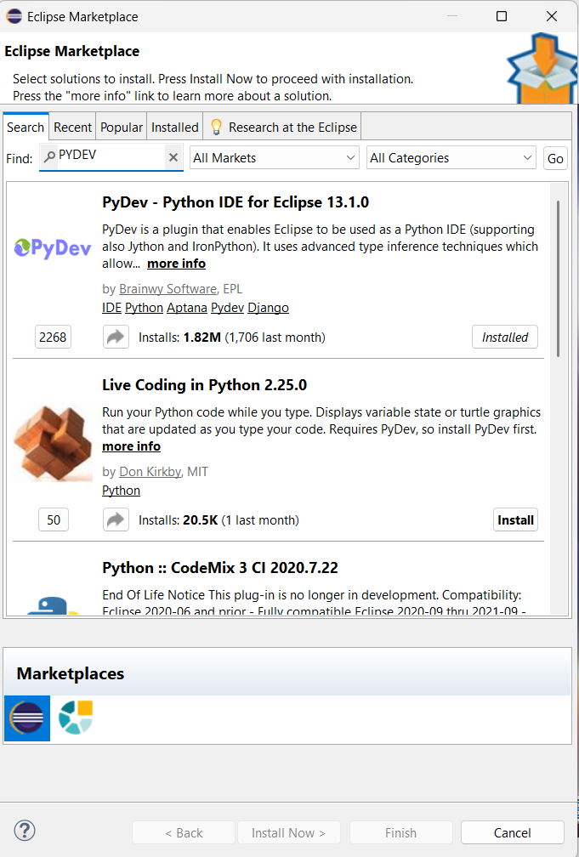
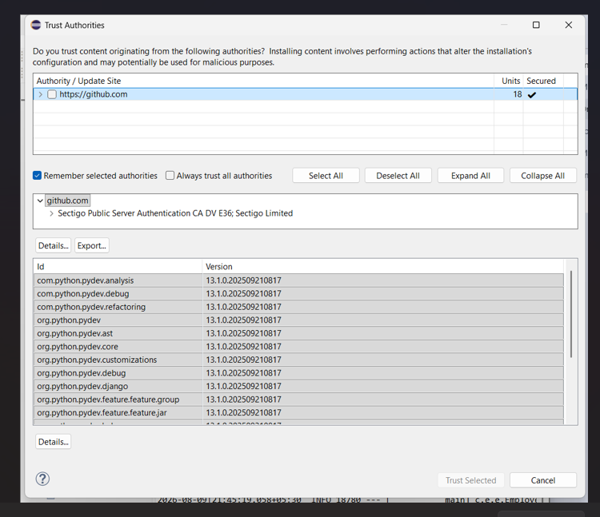
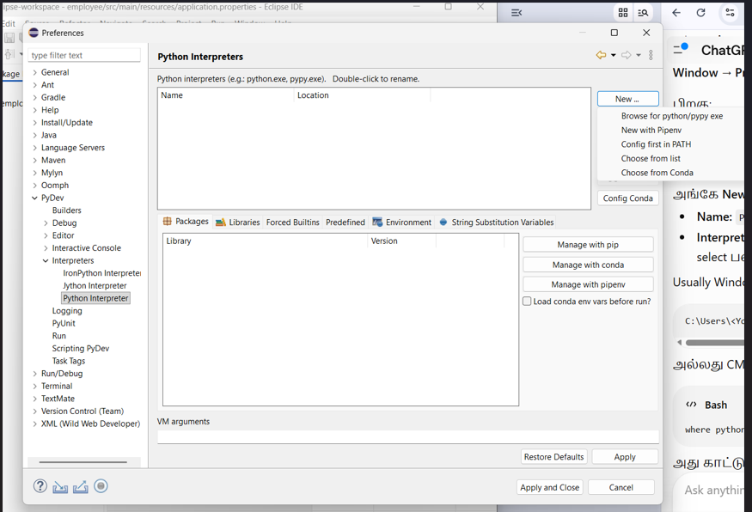
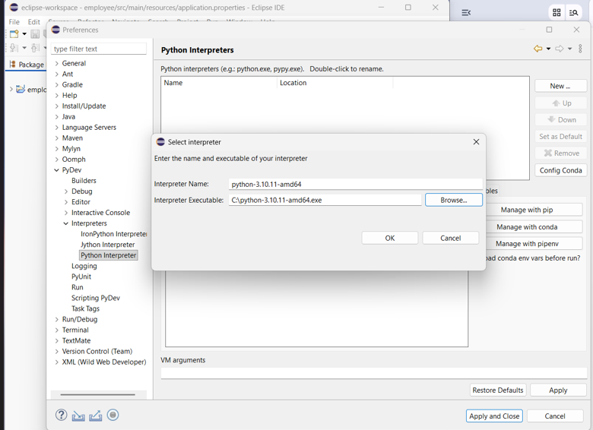
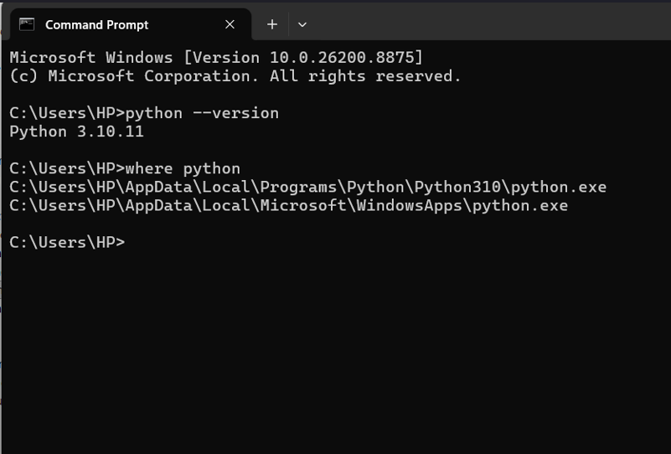
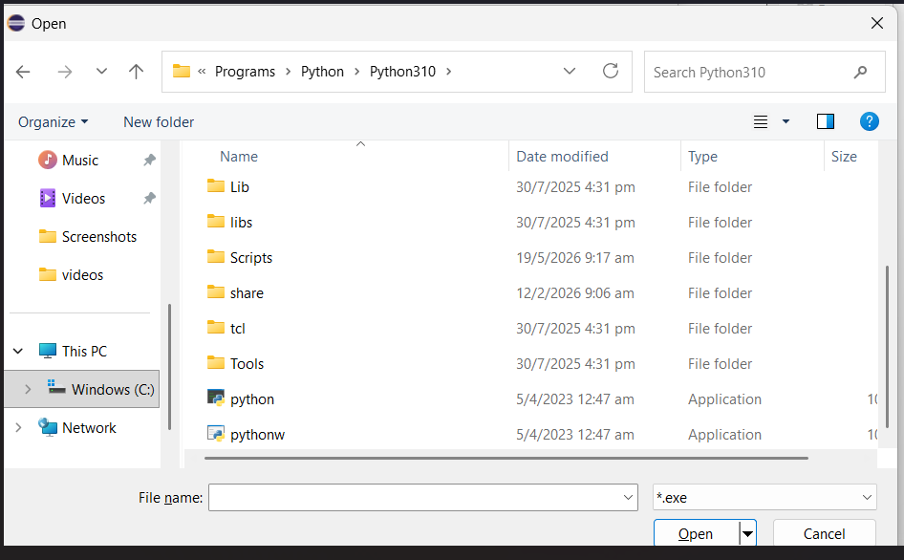
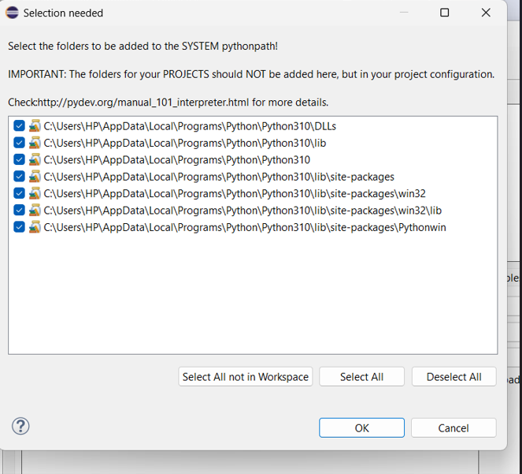

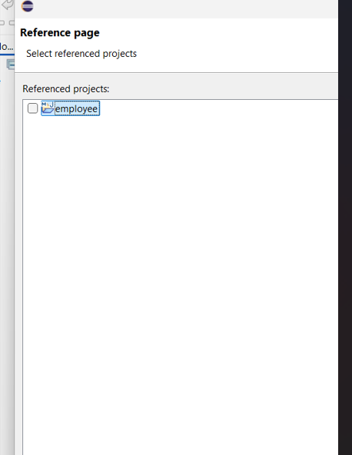
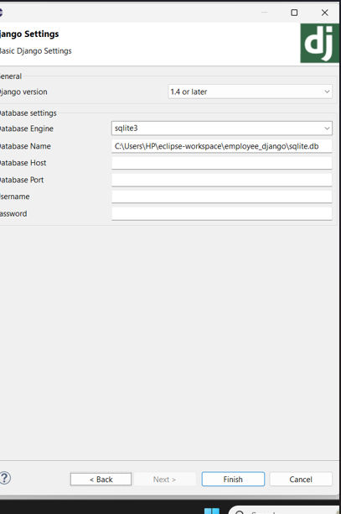
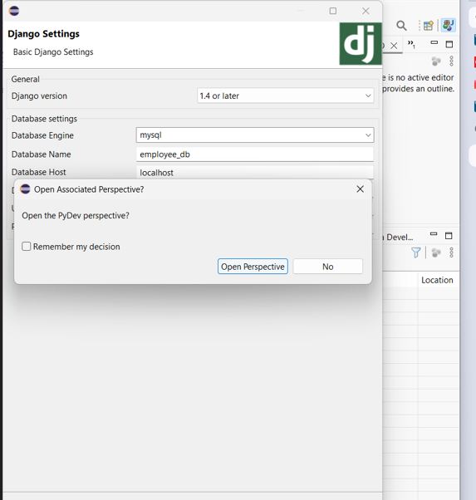
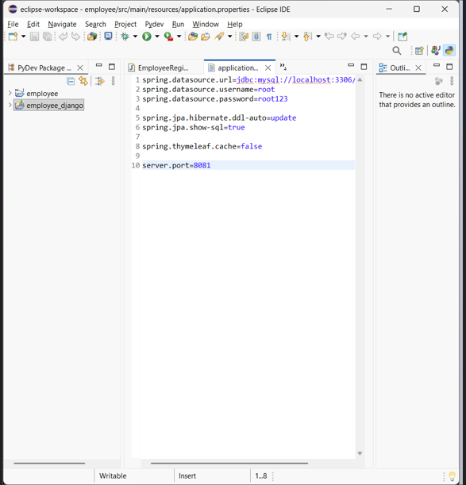

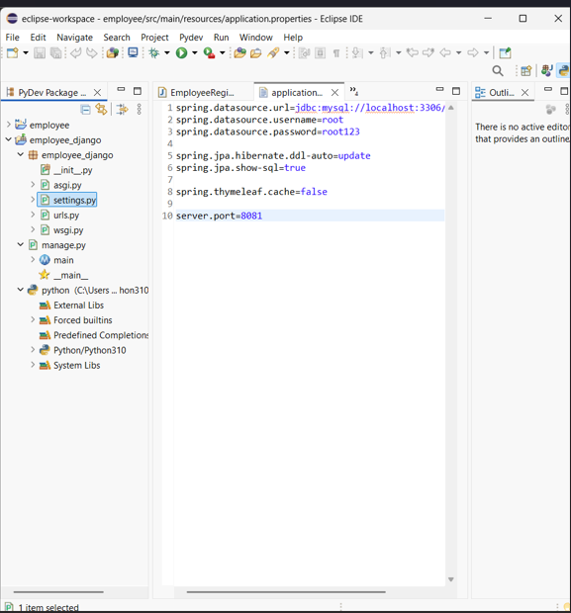
python -m pip install Django
python -m django --version
python --version
python -m pip install mysqlclient
python -m pip show mysqlclient
setting.py
DATABASES = {
'default': {
'ENGINE': 'django.db.backends.mysql',
'NAME': 'employee_db',
'USER': 'root',
'PASSWORD': 'root123',
'HOST': 'localhost',
'PORT': '3306',
}
}
Django app create
cd C:\Users\HP\eclipse-workspace\employee_django
python manage.py startapp employees
refreshapp
models.py
from django.db import models

class Employee(models.Model):
name = models.CharField(max_length=100)
email = models.EmailField()
phone = models.CharField(max_length=15)
department = models.CharField(max_length=100)
designation = models.CharField(max_length=100)
salary = models.DecimalField(max_digits=10, decimal_places=2)

def __str__(self):
return self.name
cmd: python manage.py makemigrations
cmd: python manage.py migrate
again updated code of setting.py
INSTALLED_APPS = [
'django.contrib.admin',
'django.contrib.auth',
'django.contrib.contenttypes',
'django.contrib.sessions',
'django.contrib.messages',
'django.contrib.staticfiles',

'employees',
]

DATABASES = {
'default': {
'ENGINE': 'django.db.backends.mysql',
'NAME': 'employee_db',
'USER': 'root',
'PASSWORD': 'root123',
'HOST': 'localhost',
'PORT': '3306',
}
}
Replace the code of setting.py
from pathlib import Path

BASE_DIR = Path(__file__).resolve().parent.parent

SECRET_KEY = 'django-insecure-employee-project-key'

DEBUG = True

ALLOWED_HOSTS = []

INSTALLED_APPS = [
'django.contrib.admin',
'django.contrib.auth',
'django.contrib.contenttypes',
'django.contrib.sessions',
'django.contrib.messages',
'django.contrib.staticfiles',

'employees',
]

MIDDLEWARE = [
'django.middleware.security.SecurityMiddleware',
'django.contrib.sessions.middleware.SessionMiddleware',
'django.middleware.common.CommonMiddleware',
'django.middleware.csrf.CsrfViewMiddleware',
'django.contrib.auth.middleware.AuthenticationMiddleware',
'django.contrib.messages.middleware.MessageMiddleware',
'django.middleware.clickjacking.XFrameOptionsMiddleware',
]

ROOT_URLCONF = 'employee_django.urls'

TEMPLATES = [
{
'BACKEND': 'django.template.backends.django.DjangoTemplates',
'DIRS': [BASE_DIR / 'templates'],
'APP_DIRS': True,
'OPTIONS': {
'context_processors': [
'django.template.context_processors.request',
'django.contrib.auth.context_processors.auth',
'django.contrib.messages.context_processors.messages',
],
},
},
]

WSGI_APPLICATION = 'employee_django.wsgi.application'

DATABASES = {
'default': {
'ENGINE': 'django.db.backends.mysql',
'NAME': 'employee_db',
'USER': 'root',
'PASSWORD': 'root123',
'HOST': 'localhost',
'PORT': '3306',
}
}

AUTH_PASSWORD_VALIDATORS = [
{
'NAME': 'django.contrib.auth.password_validation.UserAttributeSimilarityValidator',
},
{
'NAME': 'django.contrib.auth.password_validation.MinimumLengthValidator',
},
{
'NAME': 'django.contrib.auth.password_validation.CommonPasswordValidator',
},
{
'NAME': 'django.contrib.auth.password_validation.NumericPasswordValidator',
},
]

LANGUAGE_CODE = 'en-us'

TIME_ZONE = 'Asia/Kolkata'

USE_I18N = True

USE_TZ = True

STATIC_URL = 'static/'

DEFAULT_AUTO_FIELD = 'django.db.models.BigAutoField'
STEP 1 — employees/views.py
from django.shortcuts import render, redirect
from .models import Employee

def employee_form(request):
if request.method == 'POST':
name = request.POST.get('name')
email = request.POST.get('email')
phone = request.POST.get('phone')
department = request.POST.get('department')
designation = request.POST.get('designation')
salary = request.POST.get('salary')

Employee.objects.create(
name=name,
email=email,
phone=phone,
department=department,
designation=designation,
salary=salary
)

return redirect('employee_form')

return render(request, 'employee.html')
employee_django → Right Click → New → Folder
Folder name:
Templates
Employee.html
<!DOCTYPE html>
<html>
<head>
<title>Employee Registration</title>

<style>
body {
font-family: Arial, sans-serif;
background: #f2f4f7;
}

.container {
width: 500px;
margin: 50px auto;
background: white;
padding: 30px;
border-radius: 10px;
box-shadow: 0 4px 15px rgba(0,0,0,0.15);
}

h1 {
text-align: center;
color: #1f4e79;
}

label {
display: block;
margin-top: 15px;
font-weight: bold;
}

input {
width: 100%;
padding: 10px;
margin-top: 5px;
box-sizing: border-box;
}

button {
width: 100%;
margin-top: 25px;
padding: 12px;
background: #1976d2;
color: white;
border: none;
border-radius: 5px;
font-size: 16px;
}

button:hover {
background: #125ca3;
}
</style>
</head>

<body>

<div class="container">

<h1>Employee Registration</h1>

<form method="POST">

{% csrf_token %}

<label>Name</label>
<input type="text" name="name" required>

<label>Email</label>
<input type="email" name="email" required>

<label>Phone</label>
<input type="text" name="phone" required>

<label>Department</label>
<input type="text" name="department" required>

<label>Designation</label>
<input type="text" name="designation" required>

<label>Salary</label>
<input type="number" step="0.01" name="salary" required>

<button type="submit">
Register Employee
</button>

</form>

</div>

</body>
</html>
STEP 4 — employees/urls.py
employee_django → employee_django → urls.py
from django.contrib import admin
from django.urls import path, include

urlpatterns = [
path('admin/', admin.site.urls),
path('', include('employees.urls')),
]
Cmd : python manage.py runserver
Mysql: USE employee_db;
Mysql: SHOW TABLES;
Mysql: SELECT * FROM employees_employee;
+----+----------+----------------------+------------+------------+---------------+--------+
| id | name | email | phone | department | designation | salary |
+----+----------+----------------------+------------+------------+---------------+--------+
| 1 | Shrinidhi| shrinidhi@gmail.com | 9514475712 | CS | Developer | 35000 |

